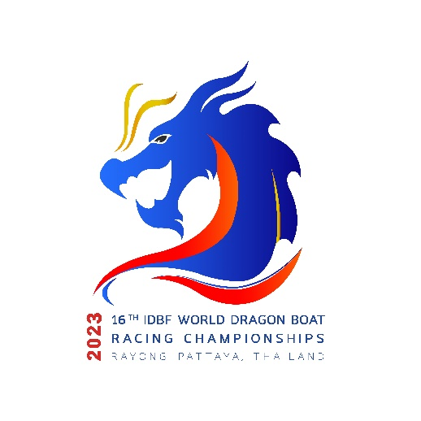

Rayong – Pattaya, Thailand | August 7 – 13, 2023

**Hotel Reservation**

**National Federation:…………………………………………………………………………………………………………………………………………………………….…….   
Team Name:…………………………………………………………………………………………………………………………………………………………….………………… Arrival Date:……………………………………………………………………………..….. Flight No.…………………………..…………………………………………….…**

**Departure Date:…………………………………………………………………………… Flight No.…………………………..………….……………………….…………..**

**Total No. of Persons:………………………………..…………………………….…… Male:……………………..…….…… Female:………………………….…….**

**No. of Hotel Rooms Required:………………………………………………………………………………………………………………………….………………………**

**Accommodation Package Fee**

1. **Kantary Hotel Ban Chang, Rayong**

|  |  |  |  |  |  |  |
| --- | --- | --- | --- | --- | --- | --- |
| **Check in Date** | **Check out Date** | **Room type** | **Rate (USD)** | **No. of Nights** | **No. of Rooms** | **Sub-Total (USD)** |
|  |  | Twin | 75 |  |  |  |
|  |  | Single | 100 |  |  |  |

1. **D Varee jomtien Beach Pattaya, Pattaya**

|  |  |  |  |  |  |  |
| --- | --- | --- | --- | --- | --- | --- |
| **Check in Date** | **Check out Date** | **Room type** | **Rate (USD)** | **No. of Nights** | **No. of Rooms** | **Sub-Total (USD)** |
|  |  | Twin | 75 |  |  |  |
|  |  | Single | 100 |  |  |  |

1. **Ambassador City Jomtien, Pattaya**

|  |  |  |  |  |  |  |
| --- | --- | --- | --- | --- | --- | --- |
| **Check in Date** | **Check out Date** | **Room type** | **Rate (USD)** | **No. of Nights** | **No. of Rooms** | **Sub-Total (USD)** |
|  |  | Twin | 85 |  |  |  |
|  |  | Single | 110 |  |  |  |

1. **Grand Jomtien Palace Hotel, Pattaya**

|  |  |  |  |  |  |  |
| --- | --- | --- | --- | --- | --- | --- |
| **Check in Date** | **Check out Date** | **Room type** | **Rate (USD)** | **No. of Nights** | **No. of Rooms** | **Sub-Total (USD)** |
|  |  | Twin | 65 |  |  |  |
|  |  | Single | 90 |  |  |  |

1. **Star Convention Hotel, Rayong**

|  |  |  |  |  |  |  |
| --- | --- | --- | --- | --- | --- | --- |
| **Check in Date** | **Check out Date** | **Room type** | **Rate (USD)** | **No. of Nights** | **No. of Rooms** | **Sub-Total (USD)** |
|  |  | Twin | 70 |  |  |  |
|  |  | Single | 95 |  |  |  |

1. **Play Phala Beach, Rayong**

|  |  |  |  |  |  |  |
| --- | --- | --- | --- | --- | --- | --- |
| **Check in Date** | **Check out Date** | **Room type** | **Rate (USD)** | **No. of Nights** | **No. of Rooms** | **Sub-Total (USD)** |
|  |  | Twin | 70 |  |  |  |
|  |  | Single | 95 |  |  |  |

1. **Golden City Rayong, Rayong**

|  |  |  |  |  |  |  |
| --- | --- | --- | --- | --- | --- | --- |
| **Check in Date** | **Check out Date** | **Room type** | **Rate (USD)** | **No. of Nights** | **No. of Rooms** | **Sub-Total (USD)** |
|  |  | Twin | 70 |  |  |  |
|  |  | Single | 95 |  |  |  |

1. **Kantary Bay, Rayong**

|  |  |  |  |  |  |  |
| --- | --- | --- | --- | --- | --- | --- |
| **Check in Date** | **Check out Date** | **Room type** | **Rate (USD)** | **No. of Nights** | **No. of Rooms** | **Sub-Total (USD)** |
|  |  | Twin | 80 |  |  |  |
|  |  | Single | 105 |  |  |  |

1. **Kameo Grand, Rayong**

|  |  |  |  |  |  |  |
| --- | --- | --- | --- | --- | --- | --- |
| **Check in Date** | **Check out Date** | **Room type** | **Rate (USD)** | **No. of Nights** | **No. of Rooms** | **Sub-Total (USD)** |
|  |  | Twin | 80 |  |  |  |
|  |  | Single | 105 |  |  |  |

1. **Classic Kameo, Rayong**

|  |  |  |  |  |  |  |
| --- | --- | --- | --- | --- | --- | --- |
| **Check in Date** | **Check out Date** | **Room type** | **Rate (USD)** | **No. of Nights** | **No. of Rooms** | **Sub-Total (USD)** |
|  |  | Twin | 80 |  |  |  |
|  |  | Single | 105 |  |  |  |

1. **Jomtien Palm Beach Hotel & Resort, Pattaya**

|  |  |  |  |  |  |  |
| --- | --- | --- | --- | --- | --- | --- |
| **Check in Date** | **Check out Date** | **Room type** | **Rate (USD)** | **No. of Nights** | **No. of Rooms** | **Sub-Total (USD)** |
|  |  | Twin | 80 |  |  |  |
|  |  | Single | 105 |  |  |  |

1. **Go hotel Ban Chang, Rayong**

|  |  |  |  |  |  |  |
| --- | --- | --- | --- | --- | --- | --- |
| **Check in Date** | **Check out Date** | **Room type** | **Rate (USD)** | **No. of Nights** | **No. of Rooms** | **Sub-Total (USD)** |
|  |  | Twin | 65 |  |  |  |
|  |  | Single | 90 |  |  |  |

1. **Welcome Jomtien Beach Hotel, Pattaya**

|  |  |  |  |  |  |  |
| --- | --- | --- | --- | --- | --- | --- |
| **Check in Date** | **Check out Date** | **Room type** | **Rate (USD)** | **No. of Nights** | **No. of Rooms** | **Sub-Total (USD)** |
|  |  | Twin | 65 |  |  |  |
|  |  | Single | 90 |  |  |  |

1. **Serene Phala Resort and Restaurant, Rayong**

|  |  |  |  |  |  |  |
| --- | --- | --- | --- | --- | --- | --- |
| **Check in Date** | **Check out Date** | **Room type** | **Rate (USD)** | **No. of Nights** | **No. of Rooms** | **Sub-Total (USD)** |
|  |  | Twin | 85 |  |  |  |
|  |  | Single | 110 |  |  |  |

**Total Accommodation Fee (USD):………………………………………………………………………………………………**

**\*All Booking subject to first come first serve basis with availability of the room**

(Bank Details for Payments would be given later)

Signature & Stamp of Federation _______________________________________________________________

Name and position of authorised signatory ______________________________________________________

Contact telephone no.: _________________________ E-mail: ______________________________________